## **Use case**

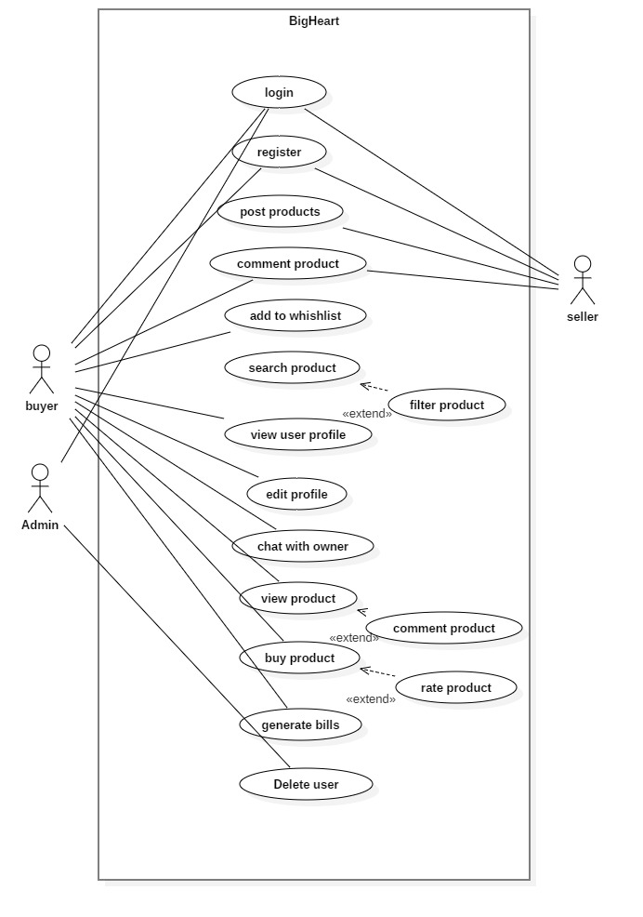

Figure 1: Use Case of E-commere

## **Class diagram**

Store

Product

Customer

Order

Shipping Address

Shopping Cart

## **Er-diagram**

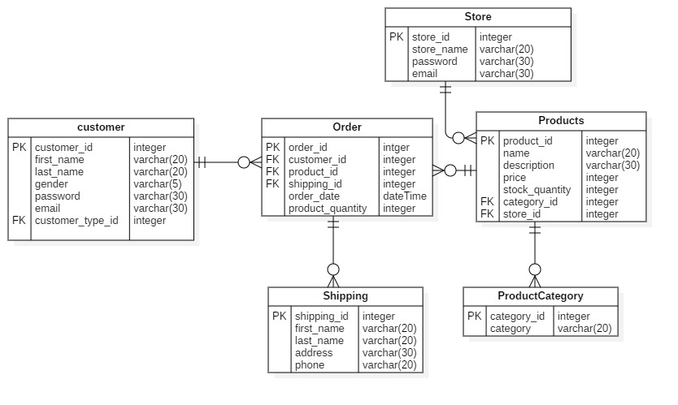

Figure 2: Er-diagram of e-commerce

## **Requirements**

**Functional requirement**

Those requirements which are related to behavioral aspect of the system. It specifies what the system should do. It includes business rule, administrative function and transaction correction.

**Non-Functional requirement**

These requirements specify how the system should behave and the limits on requirements.

## **MoSCoW prioritization**

I have prioritized my features using MoSCoW prioritization technique.

**Note**

**M**=must have

**S**=should have

**C**=could have

**W**=won’t have

|  |  |  |  |
| --- | --- | --- | --- |
| **S/N** | **Requirement** | **MoSCoW** | **Functionality** |
|  | Login | M | F |
|  | Register | M | F |
|  | Post product | M | F |
|  | Add to Wishlist | C | F |
|  | Search product | M | F |
|  | Filter product | S | F |
|  | View user profile | M | F |
|  | Edit profile | M | F |
|  | Chat with owner | S | F |
|  | Buy product | M | F |
|  | Rate product | C | F |
|  | View product | M | F |
|  | Comment product | C | F |
|  | Generate bills | M | F |
|  | Verify store owner/ seller | M | F |
|  | Delete user | S | F |

**Non-functional requirement**

|  |  |  |
| --- | --- | --- |
| **S.N.** | **Requirement** | **Description** |
|  | **Verfication** | **To verify customer and store.** |
|  | **Security** | **Protect user and system from hacking.** |
|  | **User friendly** | **To provide smooth experience.** |
|  | **Efiicient** | **Make system fast and reliable.** |